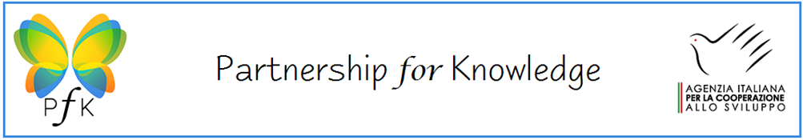
Partnership for Knowledge - PfK - is a higher education initiative of the Italian Cooperation aimed at providing scholarships to researchers, public administration officers, social entrepreneurs and young leaders.
PfK offers a unique opportunity for future leaders and influencers to develop professionally and academically, network extensively, experience Italian culture, and build lasting positive relationships with Italy.
The programme offers a number of Master of Science scholarships and PhD fellowships in the thematic academic platform of Sustainable energy, Environment and Industrial innovation. The energy profile trains highly skilled technicians in renewable energy systems, energy efficiency and energy planning. The environment profile focuses on risk protection and prevention, climate change and water management. The industrial innovation profile promotes the new frontiers of innovation.
In years 2019-2022 the PfK PhD program provides a total of 19 MSc scholarships and 6 PhD Fellowships for Citizens of Kenya, Mozambique,Tunisia, Pakistan, Albania, Lebanon and Ethiopia who are resident in their home countries.
Application procedure
The call for the PfK PhD program is now open. Applications for PfK scholarships must be submitted no later than 20 May 2019 at 12.00 pm, Italian time.
English is the teaching language of all academic programs.
Please check the website for more information
https://www.aics.gov.it/home-eng/fields/human-development/pfk/

